RRTA Meeting (in person)
December 7, 2023

Attendance: Z. Artson-Crichlow, M. Barnum, C. Bonsignore-Kitchen, P. Brody, B. Buckingham, C. Dean, L. Espinosa, K. Evans, K. Fager, B. Gerace, K. Huey, W. Humphrey, M. Jenkins-Cox, A. Johnson,, M. McCarron, L. Rapkin, G. Shakes, C. Smith, D. Sullivan, B. Swan, F. Valente, M. Zimmer
Absent: D. Altobelli, M. Ferenchak, S. Flynn, P. Givens, M. Keating. F. Macek, E. Robinson, S. Silvio, K. Schultz, A. Smith, T. Stamper Webster, Y. Wooten, J. Zuniga
Also in attendance: B. Jones, J.Kraus, S. Raymond, A. Urbanski

- The meeting was called to order at 10:06.

2. A moment of silence was observed for teachers who have passed away in the past month: James Hagen, Ruth Uhrenholdt, Ralph Zingaro. A $25 donation is made to Books for Kids in memory of any RRTA member.

3. The November RRTA minutes are posted on line within a week of the meeting. If there are any questions, contact Mary Zimmer and changes will be announced at the next meeting. Jocelyn Cox Hiler’s name was corrected from the November minutes.

4. Announcements:
a) The next RRTA meeting will be January 4 at 10 am on zoom. If interested in attending, contact Charlie Dean to get link.
b) Definitions: MAGI — Modified Adjusted Gross Income
IRMAA — Income Related Monthly Adjusted Amounts.
Charlie Dean shared the form from Medicare including Part B and D premiums determined from you 2022 tax returns. The base fee is $174.70 for everyone and if your MAGI is over $103,000 add $69.90 to the base for a single, head of household. Everyone must pay Medicare at age 65 years old. If you are receiving Social Security it comes out of your monthly check, if you are not collecting Social Security, you will be billed.
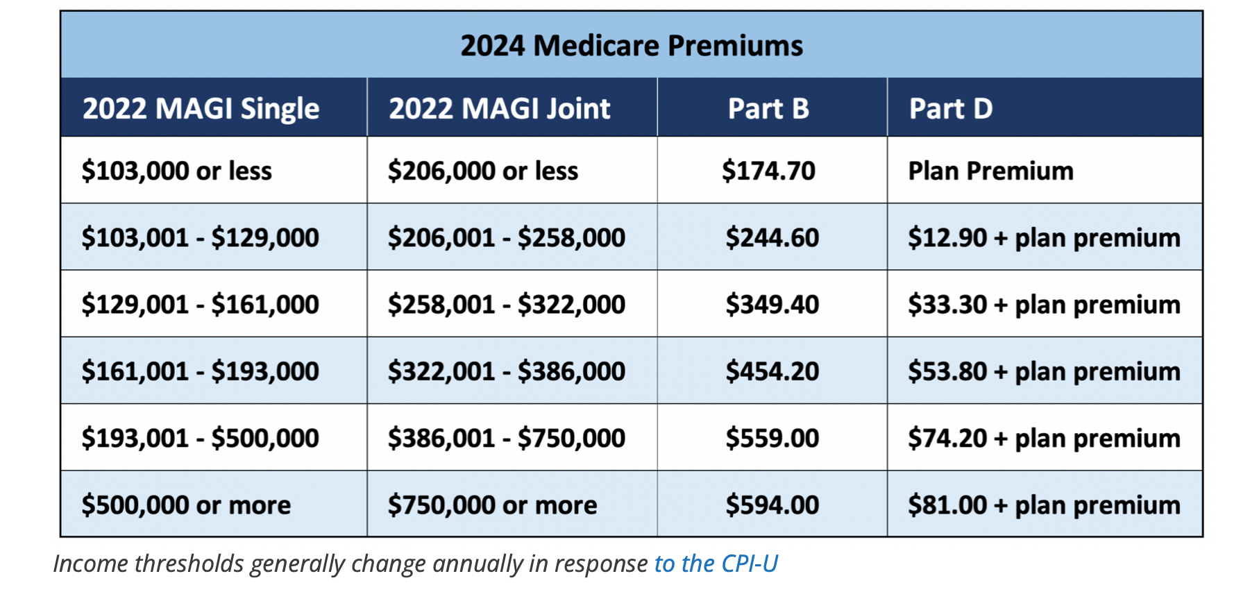
5. RRTA Holiday Party — There are 53 participants and the luncheon is December 20 at the Brook House. Canned goods are welcome and will be donated to a food pantry. The luncheon will also have a Dress A Girl fundraiser.

6. Dress A Girl/Savvy Sewers — Gaya Shakes reported that the group prepared power hygiene packs for Kenya with dresses and dolls. They sent dresses to South Sudan and Honduras and have partnered with an international group in Colorado. They are collecting money for an RCSD student scholarship. There is student from School Without Walls that is working with them as a school project and is learning to sew.

7. Vote Cope — Please continue to contribute or increase your contribution. Vote Cope oversees your pension, COLA and the Albany politicians that can determine its future. Vote Cope has begun a campaign to improve Tier 5 and 6 for inservice teachers. They are also working to increase the retiree base of $18000 to increase the yearly COLA benefit.
It was suggested to have someone from NYSUT to educate retirees about Tier 6 and how retirees can help. Jason Valenti is working with active teachers in schools to get them more involved in Vote Cope.

8. Newspaper — January 2 is the deadline for the January RRTA newspaper. Mary Barnum said she is looking for material to include. Send her anything of interest. The dues payers’ list will be included. Presently there are 553 members who have paid their dues.

9. Books for Kids — The group went to 2 first grade classes at School 52 in November. Kathy Evans said that it was a very enjoyable experience. In January the group will visit School 9.
Writers and Books are interested in becoming a community partner with Books for Kids. Allison Meyer is the contact person.
Donate to FLACE/Books for Kids as a tax deductible donation.

10. RRTA Calendar — December 20 is the Holiday Party at the Brook House
January 4 - next RRTA meeting

11. New Business —
a) Mary Barnum wants to make everyone aware that RTA has the policy to ask all committee members to watch the NYS sexual harassment video annually. RRTA, Dress a Girl and Books for Kids members will be receiving a letter about it. Please sign the letter and return it to RTA.

b) A motion from the RTA, November 28 meeting was discussed. At the meeting an active teacher proposed that RTA reps be paid. It was said that unions are based on volunteers and working together.
It was also stated that many new and older reps do not know the history of RTA and the rules of order. It was said that reps need the training as a rep. Aimee and Margaret do training yearly for reps and the reps get paid for attending the training.

c) A motion was made that for the December, January, February and March RRTA meeting be held on zoom. An amendment to the motion to exclude December was made and passed. The motion to have RRTA meetings on zoom for January, February and March passed 11 to 8.

The meeting adjourned at 11:23.

Mary Zimmer
RRTA Secretary

