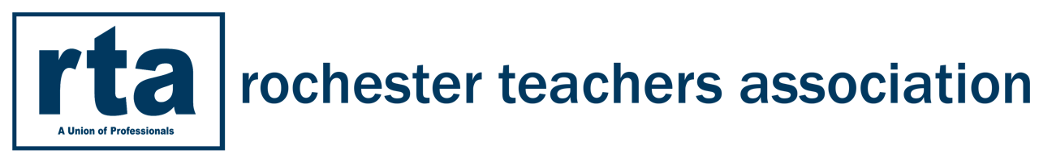 Action Research Proposal

”Action research is a disciplined process of inquiry conducted by and for those taking the action. The primary reason for engaging in action research is to assist the “actor” in improving and/or refining his or her actions.”
Copyright © 2000 by Association for Supervision and Curriculum Development
Action Research is a systematic inquiry done by teachers to gather information about, and subsequently improve how well their students learn. Although there are a number of models for doing action research, the basic process consists of four steps: identify an area of focus, collect data, analyze and interpret data, and develop an action plan.

Name of Facilitator:

- With the members of your action research group; write a thoughtfully crafted “Area-of-Focus Statement” for relevant action research.

- Define the Variables of your action research plan. (A variable is a characteristic of your study that is subject to change; your teaching, student outcomes, etc.) Defining variables will assist you in selecting the type of data collection that you will use.

- Develop Essential Questions/Professional Learning Targets to guide your work. (You will need to provide an agenda and minutes for each meeting that reflect the EQ and targets for that session).

- Develop a statement of resources: (Central text, as well as 2-4 additional resources that directly relate to your area of focus; books, articles, Internet reports, etc.)

- Develop measurable data collection ideas: (Some suggestions include: surveys, questionnaires, exhibits, portfolios, interviews, rating scales, inventories, visual recordings, photography, journals, mapping, teacher-constructed pre and post tests, student work)

- Describe the membership of the action research group. Provide all names and why each member is important to the group.

Please submit this form and the attached timeline to Annamaria.Manso@RCSDK.org no later than NOVEMBER 1st. If you are making changes to the attached suggested timeline, please make sure you attach your revised timeline. Teachers conducting Action Research that meet the expectations below will receive 16 hours of PD credit for this school year.

Action Research Project Timeline and Expectations

November 1st Action Research Plan due to RTA Program Director
The team
- Will decide on a team facilitator or will agree to rotate the role.
- Will read [text related to topic]
- Will meet to discuss assigned chapters and to identify strategies to try.
- Will meet to discuss the impact of the strategies being used.
- Decide on a pre-assessment to use with students (eg. writing assignment, lab, pre-test, etc.)

November-December
The team
- Will decide on a base line assessment and give it to their students in early September. (This is considered initial data.)
- Will analyze the initial data to assess areas of strength and weaknesses.
- Will meet with each other in late September/early October to discuss the baseline assessments and to review possible strategies to use.
- Will implement some of the suggested strategies in the text.
- Will videotape a lesson in which at least one of the strategies is being used. (This is considered data to examine.)
- Will meet with each other to discuss the impact of the strategies being used.
- Will modify instruction as necessary based upon the ideas gathered from the resources that are being read, the discussions taking place at the meetings and/or workshops attending.

December-May (Realign your area of focus and Action Research Plan when necessary.)
The team
- Will meet to continue to discuss how to modify instruction as necessary based on the ideas gathered from the text, the discussions taking place at the meetings and/or workshops attending.
- Will continue to discuss the strategies each member is implementing.
- Will continue to implement the chosen strategies from the text.
- Will videotape a lesson in which one of the strategies is being used. (This is considered data to examine.)
- Will meet with each other in March to discuss the impact of the strategies being used.
- Will give a post-assessment to compare to the pre-assessment.
- Will meet in May to have a reflective discussion about the strategies implemented and to determine future direction of the Action Research.
- Will submit a reflection to Annamaria Manso @ 30 North Union Street, no later than May 1st, 2024

