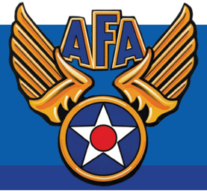
Air Force Association — Teacher of the Year

Rochester Teachers Association and Air Force Chapter 308 have joined “forces” to recognize up to 2 classroom teachers for their accomplishments and achievements in exciting K-12 students about science, technology, engineering, and math (STEM).

Any RTA Representative or building Administrator may submit a maximum of two nominations per building. Each nomination must be submitted on a separate form and include the reason(s) why that teacher should be considered.

In order to be considered for this award, please send the completed nomination form, a letter of recommendation from the person nominating the teacher, and a letter of recommendation from the school administrator to RTA c/o Aimee Rinere, 30 N. Union St., Suite 301, Rochester, NY 14607. You may also email the packet to arinere@rochesterteachers.com or fax to 546-4123.

A joint committee will review all applications received by April 12, 2018. Winner(s) will be recognized at their school, date TBD. Winner(s) will receive a check for $250.00, a Certificate of Excellence, an AFA pad-folio, and a Chapter Teacher of the Year pin.

Please help in recognizing your colleagues who are preparing our students to use and contribute to tomorrow’s technologies.

Former Winners of “Teacher of the Year” Award from AFA & RTA:
2012 Peter Mastrogovanni #8
2013 Martha O’Duffy #9
2014 Logan Newman East High
2016 Peter Mastrogovanni #3
Vici Patanella #3
Tina Rodger #3
2017 Logan Newman East High
2018 Julie Ricciuto #29
Wendy Ferris #29
Jennifer Rothfuss #23
Nghia T. Tran #8
Toni Stevens-Oliver Thornell Rd., Pittsford
2019 Apply so you can be the next “Teacher of the Year”

