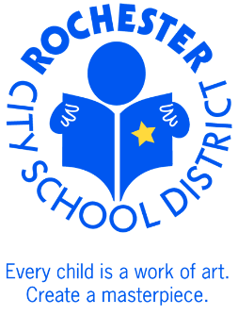 |  | Aneli Rivera-Nothnagle, MBA, SPHR  Director Employee Benefits  Rochester City School District  131 West Broad Street  Rochester, New York 14614  Phone: 585-262-8586  Fax: 585-295-2614  www.rcsdk12.org
October 27, 2017

Dear RCSD Retiree:

I am writing to notify you that for the 2018 Benefit Plan year, you will have an option of electing retiree dental coverage through MetLife.

This is a voluntary dental plan, meaning that the District does not contribute towards the premiums. Premiums vary based on your home location and the plan you select. For example, a rate for someone living in Rochester, NY will be less expensive than a plan for a person living in New York City. The rate for the PPO low plan will be less expensive than the rate for the PPO Medium or PPO High plan.

If you choose to elect the Dental coverage, the contract will be between you and MetLife and they will bill you directly.

To find out more information about the plan, including rates, you can:
- Go to https://www.metlifetakealongdental.com or
- Call 1-844-2METDEN

MetLife will be present at the Retiree Open Enrollment Meeting scheduled on Thursday, November 9, 2017 from 3:30 to 6 PM at the Edison Tech Auditorium at 655 Colfax Street, Rochester, NY 14606. They will be providing information on the plan as well as answer questions. Information will also be available on the Rochester City School Website: https://www.rcsdk12.org/Page/29336.

Sincerely,

Aneli Rivera-Nothnagle
Director of Employee Benefits

